

Rapid Snapshot
User Guide

Last Updated: July 24, 2018

Table of Contents
1. Introduction 3
2. Schema Management 4
3. Connection creation 7
4. User Management 10
5. Snapshot creation 11
6. Snapshot Details 14
7. Snapshot Filtering 17
8. Snapshot documentation (BR100) 19
9. Snapshot Comparison 21
10. Options 23
11. Inventory Management 27

1. Introduction

RapidSnapshot is a standalone PC software which interacts with the Oracle E-Business Suite Database. The purpose of RapidSnapshot is to quickly snapshot Configurations in order to document, view, audit, download or compare those Configurations across a timespan (days, months, years).
This Document will guide you on how to use all the functionality that this software provides.

In any case of questions, feedback or issues, you are welcome to open a support ticket on our website at

http://www.rapid4cloud.com/ticket/

2. Schema Management

The first step to perform once you install RapidSnapshot is to register the product. Please follow the instructions on the screen to do so.
Once the registration is complete, you can start using the product.

Then you will need to create a RapidSnapshot Schema. The Schema is like a working area containing all the snapshots of configurations for your EBS instance.
Note that the Schema will be automatically created on the EBS Database and as such only a Database Administrator (DBA) can perform that action.
You will need the DBA to repeat that operation for every EBS instance. It also is recommended one schema for each Consultant using RapidSnapshot to avoid conflicts.
Although, you can share a single schema among multiple consultants but only one of them will be able to create snapshots at a time.

- Click on the Top left image to access the Menu, then “Schema Management“

- The DBA will need to enter the information to connect to the Oracle EBS database as SYS. Then, the DBA will need to click 'Connect'.

- The DBA will need to enter the information to connect to the Oracle EBS database as SYS. Then, the DBA will need to click 'Connect'.

- The next screen appearing is the interface to create the necessary schemas. It is intended to be used by the DBA.
  - The left panel will show you all the RapidSnapshot Schemas already created.
  - The right panel contains fields to create new schemas. All the fields to fill in are straighforward for a DBA.
  - Once the information is provided, click CREATE in order to start the background proces of creating the schema. The DBA can click VIEW SCRIPT to understand/ review the SQL commands that the background process will execute on the Database.
  - Once the schema created, the DBA can then create more schema or close that window.

3. Connection creation

Once the schema created, a connection is automatically generated for that schema. The DBA can share that connection to any Consultants. The folder containing all the connections is located by default in installation folder under the “snapshot-servers” directory.

- Click the ADD button to define a new connection.

- Enter the Schema information and Click SAVE. If you are unsure of what to enter, then ask your DBA for help.

- Select the connection from the Drop down list then click CONNECT.
- Note that you can also change some information or delete a connection using the EDIT or DELETE buttons.

- If the connection information is correct, then you should see the following status: “Connected”. Otherwise, contact your DBA for help.

- Once connected, the list of all the current snapshots will be displayed on a grid or nothing if there are no available snapshots. In that case, go to the next section on how to create a new snapshot.
- The grid provides information on every snapshot like name, when it was created, by whom, how many Configurations records were copied, status of the snapshot. It also displayed a “Inventories” Count.
“Inventories” are the basic blocks of a Oracle Configuration Form. Usually an Oracle Form is composed of many areas with each area having many fields. Also, a relation of Master/ Details (Parent/ Child) relates all those areas together. Those areas are called “Inventories”.
- From the grid, you click the VIEW button (black eye image on every line of the grid) in order to view the Details of the snapshot. You can also DELETE a snapshot if you don't need it anymore. (This delete is a soft delete, it does not actually remove all copied configurations from the snapshot).
- You can also see a total of many Configurations were copied, a total of how many Configurations were added or updated.
- The bottom information outside the grid contains information on the disk size (in GB) of all the snapshots stored in the current connection.
- The “Reset Connection” button is used if you need to restore a connection to its initial state, meaning it will remove all the snapshots stored from the Oracle DB, this operation is unreversible so use with caution.

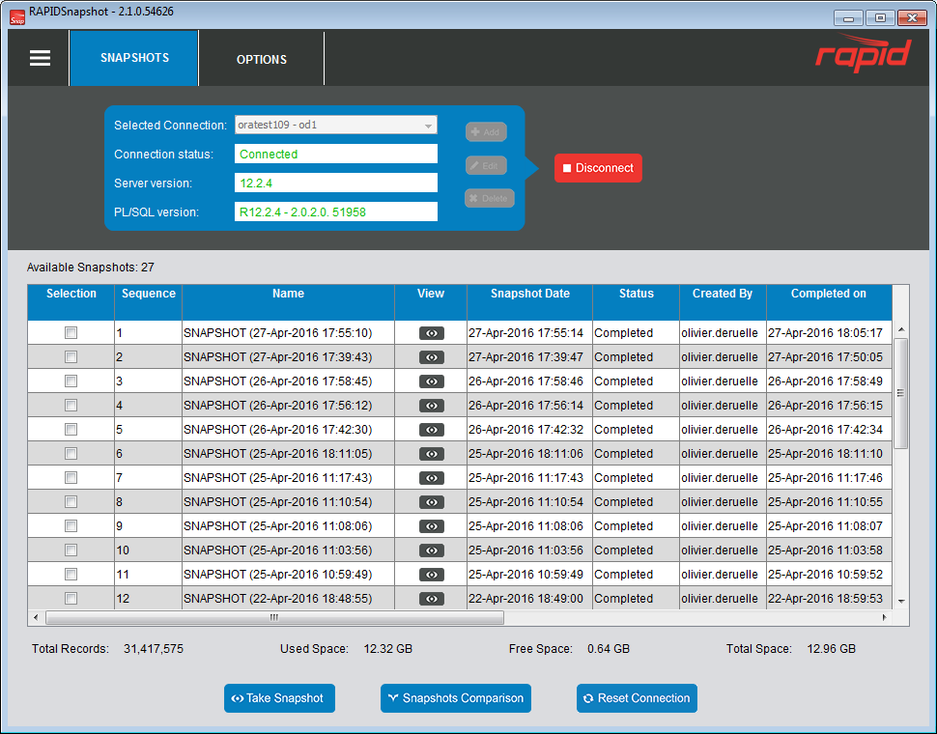

4. User Management
This window is used in the case where you want to share a single schema with multiple consultants. This is an optional feature so you can still decide not to implement it for your schema but once a user is defined, then you cannot go back to a non-user management model.
Note that there is a limitation of only a single snapshot can be created at any time:
Only one user will have the creation permission but this permission can be transferred to any other users.
On the main menu, click on the “User Management” sub menu:
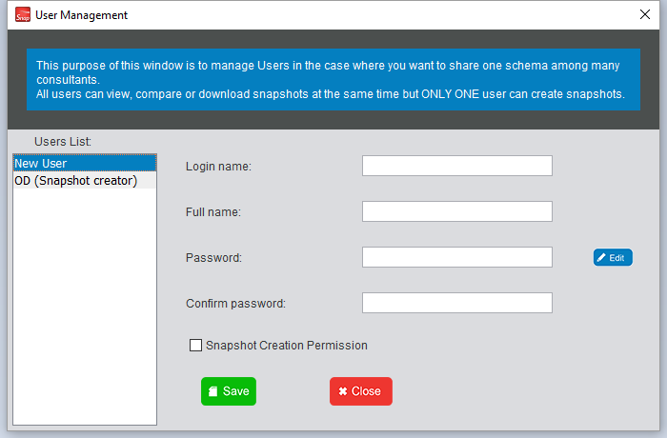
Click on “New User” on the left panel then fill in the information related to the user. Select the “Snapshot creation permission” checkbox if you want this user to be able to create snapshots.
Note that a user cannot be deleted once created, you can reset his password with the “Edit” button but only the DBA can do this (the SYS password will be required).

Once you want to create a new snapshot, a login window will appear for you to enter your login name and password.
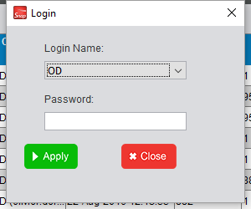

5. Snapshot creation
Once connected, you will want to view your Oracle Configurations. In order to do that you will need to create a snapshot. Creating a snapshot will copy all the Oracle Configurations of your EBS instance into the working area of your schema. All Configurations still remain in your EBS instance.

- Click “Take Snapshot” to start the process.
- A new window will show the listing of all the inventories that can be snapshot'ed.
- You can select/ unselect inventories as you wish by clicking the Selection checkbox or shift-select and right-clicking on the rows then use the sub menus (select all/ unselect all)
- You also can filter the inventories by Oracle Application name (use the green button to view all the supported Application names)
- Once ready, click SNAPSHOT to start the process.
- Once the process completed (Progress label), you can review the results then close the window to return to the main screen.
- Note that you can cancel the snapshot in progress at anytime by clicking CANCEL.

6. Snapshot Details

Once your snapshot is completed, you can view the details of your Oracle Configurations using the VIEW button on the main grid.

- It will display a new window containing the details at the inventory level.

- The “Total Default Records” contains the total number of Configurations records that are seeded by Oracle when installing EBS.
- The “Total Added Records” contains the total number of Configurations records that were added by your Consultant.
- The “Total Updated Records” contains the total number of Configurations records that were changed by your Consultant (based on the seeded records only).

- You can view your Configurations by clicking the VIEW button at the inventory level.

- Note that you can also SAVE the grid to Excel format for offline review if needed.

- In the “View Record” window, you can view all data for all fields in the Form along with Audit data.
- You can download your Configurations by clicking the DOWNLOAD button.
Note that only the inventories filtered on the grid will be downloaded so you need set your filters appropriately before downloading.
- The downloaded configurations are stored in Excel files by default.
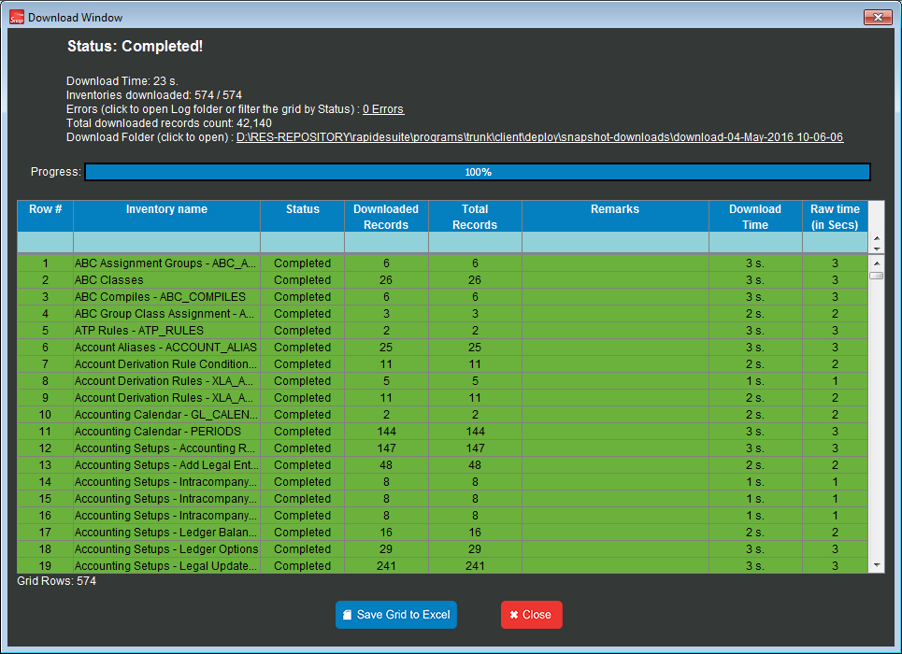

7. Snapshot Filtering
Snapshots usually contains a lot of information: many Oracle forms from many modules, with configurations created or updated by many Consultants on different dates.
Filtering those by criterias is very useful for you in order to find quickly the information that you are looking for.
You can filter by Oracle Application names, Oracle users, Dates, Operating Unit names, Oracle form names, menu paths,...

- Set you filters using the various blocks.
- Click APPLY FILTERING when ready to refine your search.
- Click RESET FILTERING if you wish to return to the default settings.

- General Options Filtering:
- “Show only Forms with Changes”: this setting will display inventories that have Configurations changes only (Added/ Updated counts).
- “Show Instance Level Forms”: use this setting if you want to show only the global forms, ie forms that are shared for all Operating units.
- Operating Units Filtering: use this setting if you wish to view configurations for specific operating units only.
- Users Filtering: use this setting if you wish to view configurations changed by specific Oracle users.
- Date Filtering: use this setting if you wish to view configurations added/ changed after or before a specific date range.
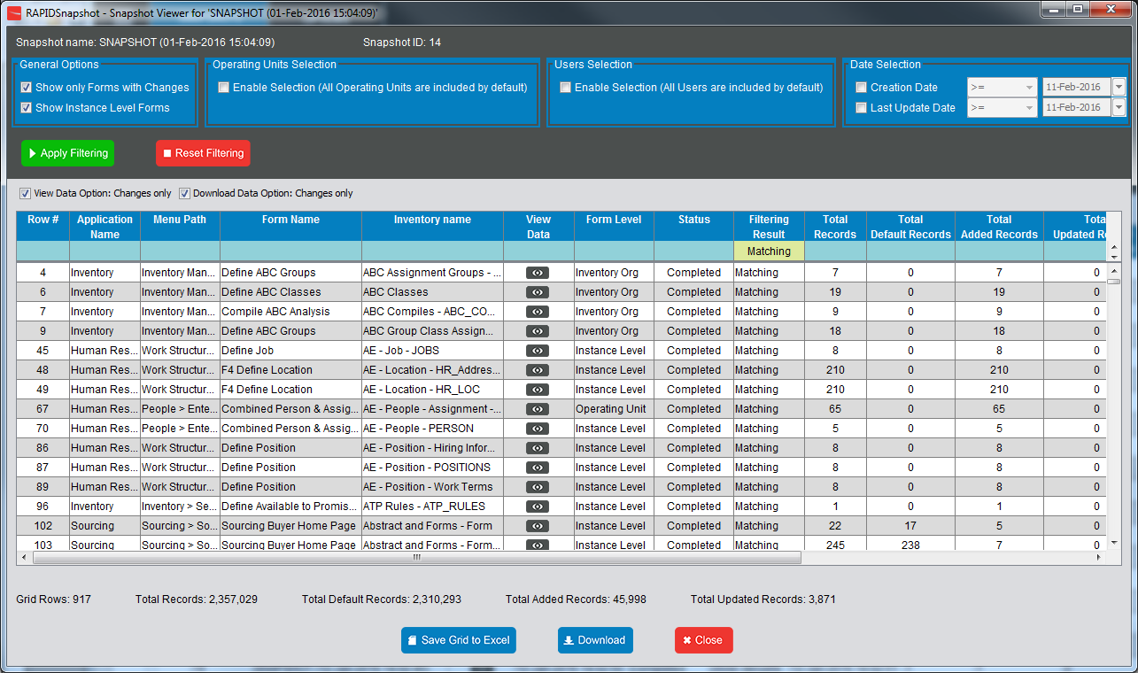

- You can also use the light blue Filtering bar to refine your search based on any columns showing in the datagrid.
Note you can use “>” or “<” signs for filtering numbers (example: “>1000”: search for all the forms with a total number of updated configurations greater than 1,000).

- There are two filtering options related to viewing/ downloading Configurations:
- “View Data Option: Changes only”: this setting will control retrieving Configurations, in the Record View mode, that have changed only so not showing all the seeded Oracle configurations.
- “Download Data Option: Changes only”: same logic, this setting will control downloading only Configurations that have changed thus reducing the amount of data.

8. Snapshot documentation (BR100)

The configurations can be downloaded in Excel format which can be used as a BR100 report.
All the downloaded files reside in the filesystem under a common folder.

This is a basic functionality, however there is also a much nicer report that can be generated in Excel format containing all the tables in one single file with the Table Of Content. Also, the configurations are separated between Adds, Updates, Deletes.
This enhanced report can then be distributed to Management or Audit officials for ease of review.This functionality is available only for the paid version of RapidSnapshot, please consult our sales desk for further information.

Basic report:

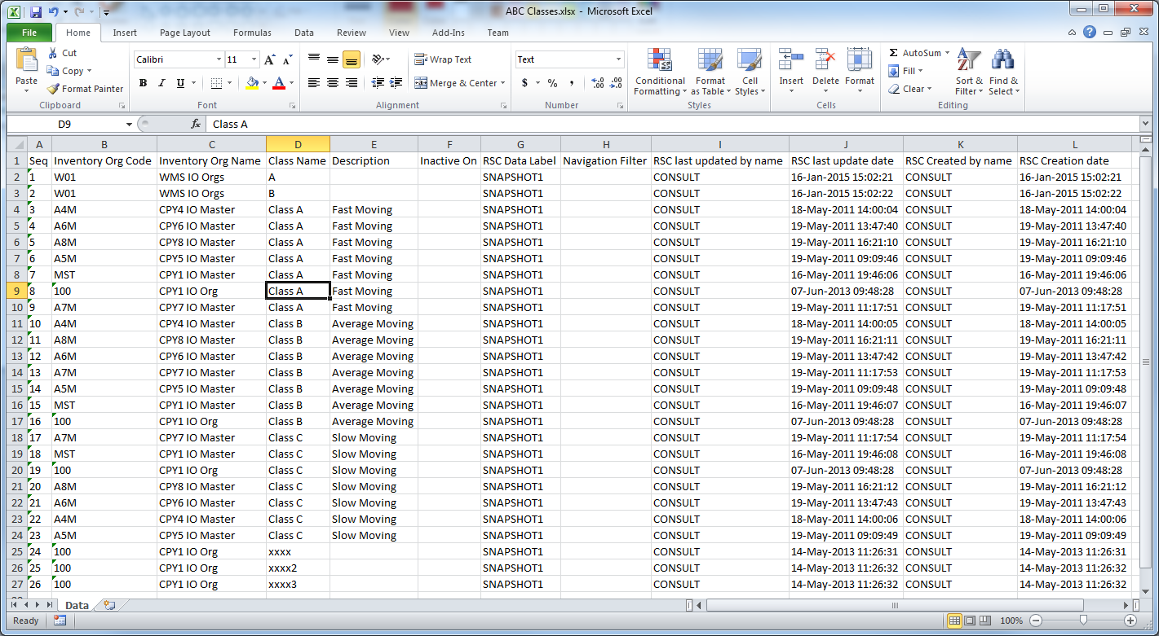
Enhanced BR100:
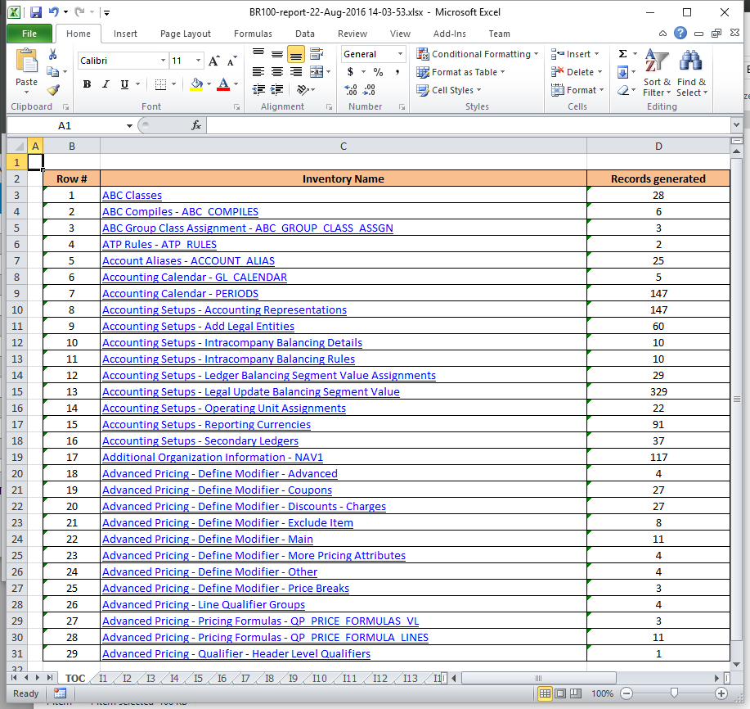
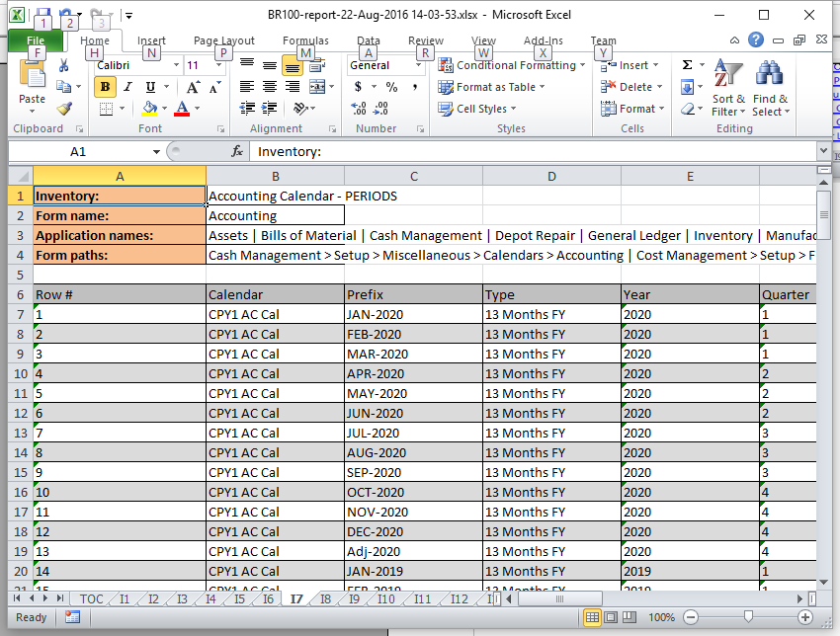

9. Snapshot Comparison
You can compare multiple snapshots to analyze only the changes made between them.
Note that you can compare up to 5 snapshots.

- Select 2 or more snapshots from the snapshots list.

- Click the SNAPSHOTS COMPARISON button.

- A new window will appear showing only the inventories that have changed between the selected snapshots.

- You can download the changes by clicking on the DOWNLOAD button.
- You can view the changes by clicking on the VIEW button. Note that the changes are highlighted in yellow.
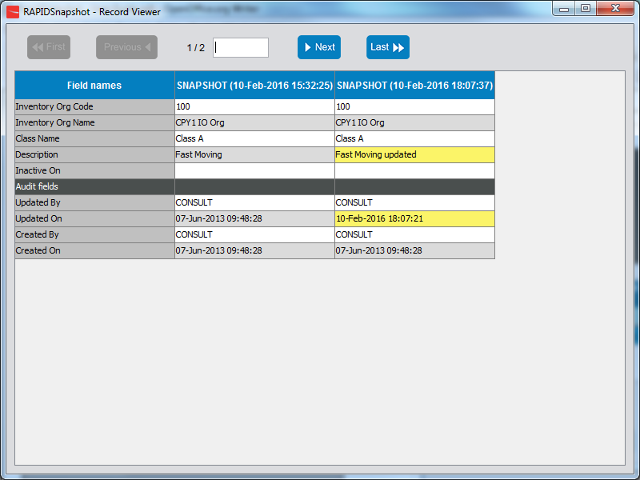

10. Options
The Options panel provides a way to set and save your preferences when using RapidSnapshot.

- Default Parallel Workers: you can set the maximum number of concurrent SQL executions. RapidSnapshot executes one SQL query per Inventory when taking a Snapshot, since it may have up to 3,000 SQL queries to run, it will take some time if all those queries were to be run in sequence. So, by increasing the value in this field, RapidSnapshot will start many SQL queries in parallel thus reducing the time it takes to snapshot your EBS instance. Note that the optimum value depends on how your Oracle Database is setup in terms of performance (CPU, SGA,...). Please check with your DBA if you are unsure on what to change this value to.

- Server Connections Default Folder: you can change the folder where all your connections are stored. Everytime you add, edit or delete a server connection, then it will update the files in that folder. Note that you copy this folder to another RapidSnapshot installation to avoid of recreating the connections.

- Download Folder: you can change the default folder where all the Excel files will be stored when clicking the DOWNLOAD button in the Snapshots details window.

- Default Snapshot name prefix: you can change the default prefix provided when creating a new snapshot.

- Download Format: by default the downloaded files will be in Excel format but you can also set them to XML (better format if those files are to be imported in RapidConfigurator).

- Display unsupported Inventories: unchecked by default. Many inventories do not have any SQL developed for so they are flagged as Unsupported by RapidSnapshot; this means that you will not be able to snapshot Configurations for those inventories (Oracle Forms). This feature is mainly targeted for the Rapid Development team. You can also request some additional forms to be developed (usually this comes with a price tag).

- Display Total Details (Default/ Added/ Updated): unchecked by default. This setting will display the Grand Totals of default, added and updated Configurations for each snapshot. This will greatly affect performance as it takes time to compute this information for each snapshot.

- Display Help balloons on start: checked by default. This setting will display Help Balloons on startup to guide new users on where to click.

- Seeded users definition: This setting controls how the Default/ Added and Updated totals are computed.
Basically, “Default” (seeded configurations) are all configurations which were created by (using the WHO database columns) Oracle seeded users.
You can tweak the list of users in this setting but it is not recommended to change it only if you know what you are doing. The list of users needs to be single quoted comma separated Oracle user names.
“Added” are all configurations NOT created by seeded users.
“Updated” are all configurations updated by non-seeded users (standard Oracle users).

11. Inventory Management

Inventory Management provides you an ability to exclude or include inventories in various Rapid Snapshot functionality.

Within the Admin Menu the Inventory Management menu lists all available Inventory Names with two custom options available, ‘Executable’ and ‘Retrievable’ for an Administrator to choose.

These two options influence functionality within the tool on:
a) How inventory collection scripts are accessible for execution and
b) How retrieval of collected inventory data is accessible from the RAPIDSnapshot database tables (contained within a snapshot).

A RAPIDSnapshot Administrator account must first establish a database connection (by clicking on ‘Connect’ button for the ‘Selected Connection’) and then click the menu bar on the top left selecting Admin Menu : Inventory Management.

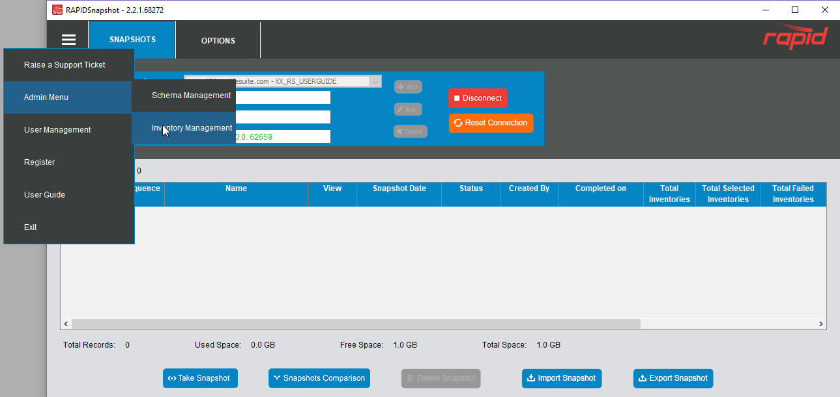

- Inventory management window grid will appear, listing all inventories which related to scripts installed and two options “Executable” and “Retrievable” can be modified
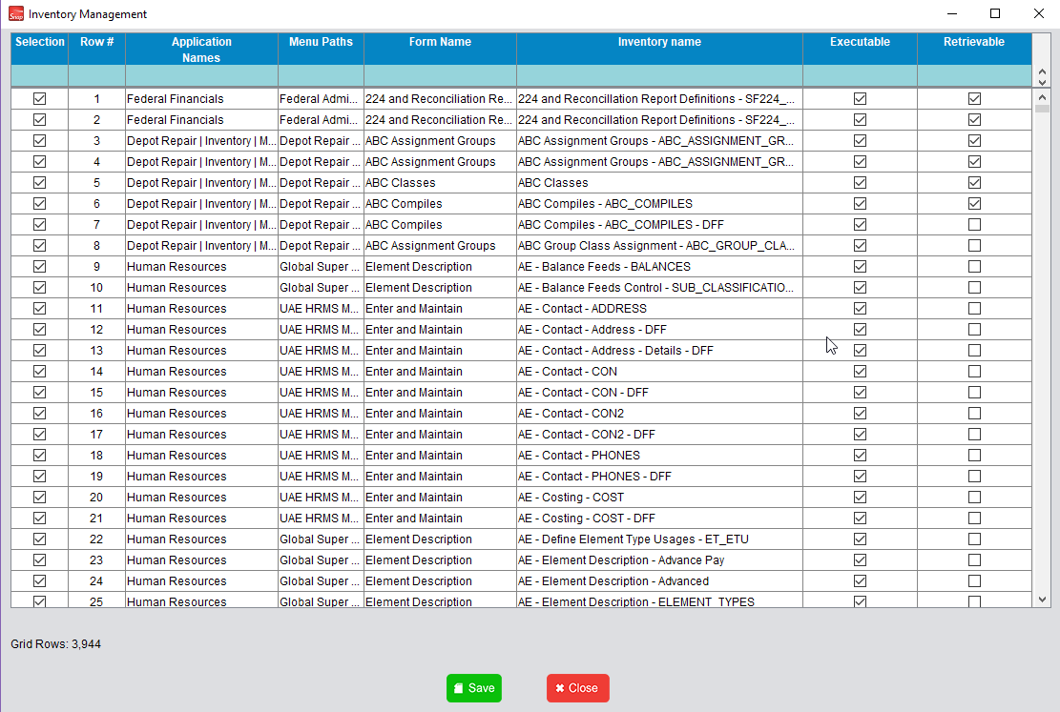

a. Executable :
If checked, when creating snapshots to run in the database, this inventory collection sql script is allowed to be executed.
b. Retrievable :
If checked, when retrieving snapshot data collected and stored in the RAPIDSnapshot database schema tables, this inventory data will be displayed to the end-users.

Note: Because these options above are stored in a <rapid-snapshot-schema>.INVENTORY
database table as IS_EXECUTABLE for Executable and IS_LISTABLE for Retrievable, individual-independent schema installations of the RAPIDSnapshot inventory table can represent different lists of inventories.

Example1 : Wanting to prevent all inventories, for ‘Human Resources’

- From displaying as ‘Executable’ inventories on the ‘Snapshot Creation’ submission menu.2.
- From displaying as a 'Retrievable' inventory any ‘Snapshot Data’ collected for the same list of inventories that ‘Executable’ was turned on in the past or is off for the future.
These two settings apply to all end-users registered in the <rapid-snapshot-schema>.USERS table currently residing as ‘Enabled’ users that are able to use the RAPIDSnapshot tool to submit and/or review inventory snapshots from the schema snapshot tables linked to in the database after clicking on ‘Connect’ button for the ‘Selected Connection’.
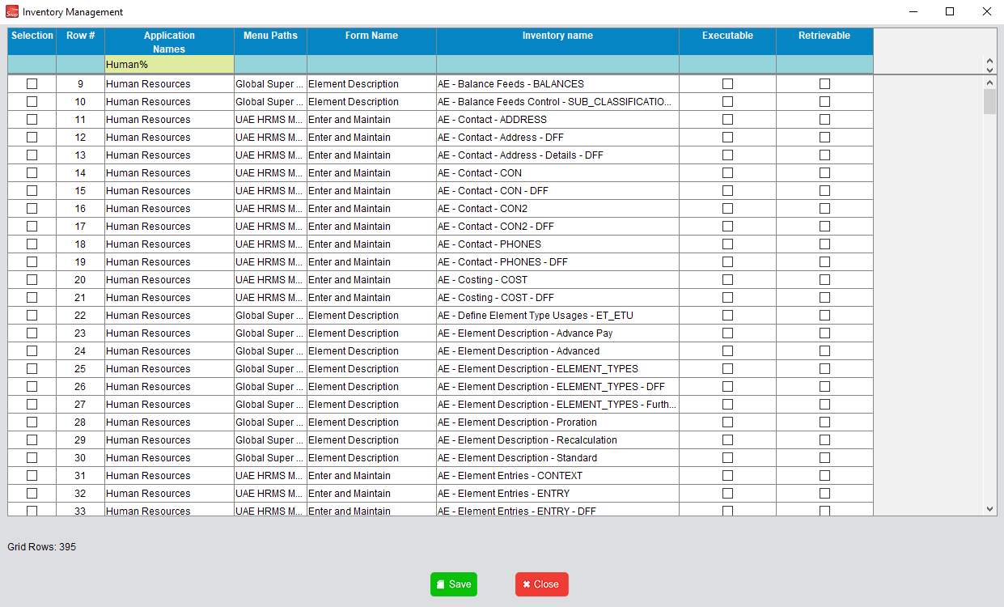

- Then click 'Take Snapshot' and check if it contains any inventories under 'Human Resources'

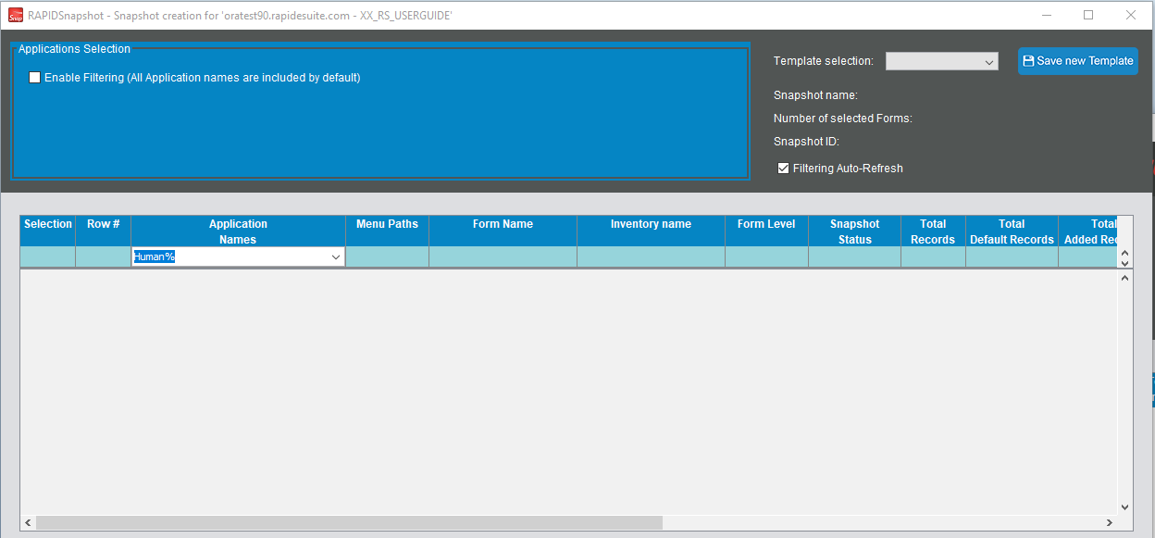
There are no inventory under 'Human Resources' showed in the grid anymore.

Example 2 : The ‘Executable’ inventory option turned off in Example 1 are turned backed on to demonstrate the ‘Executable’ inventories being available for ‘Snapshot Creation’ the Snapshot Submission menu list again.

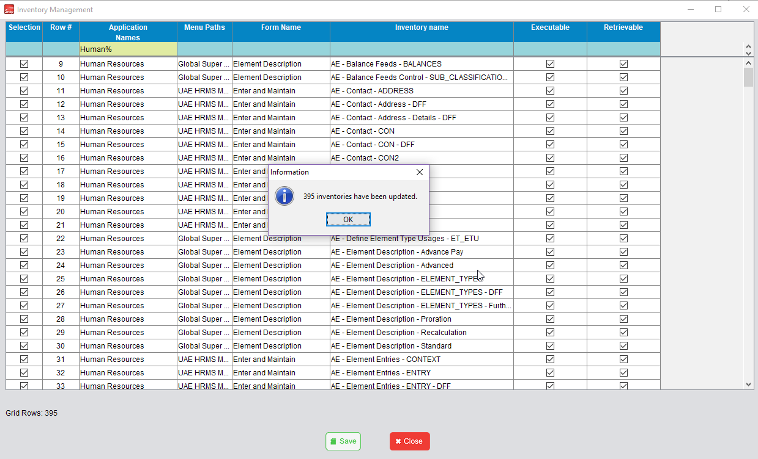

Click 'Take Snapshot' and check if there is inventory under 'Human Resource'.

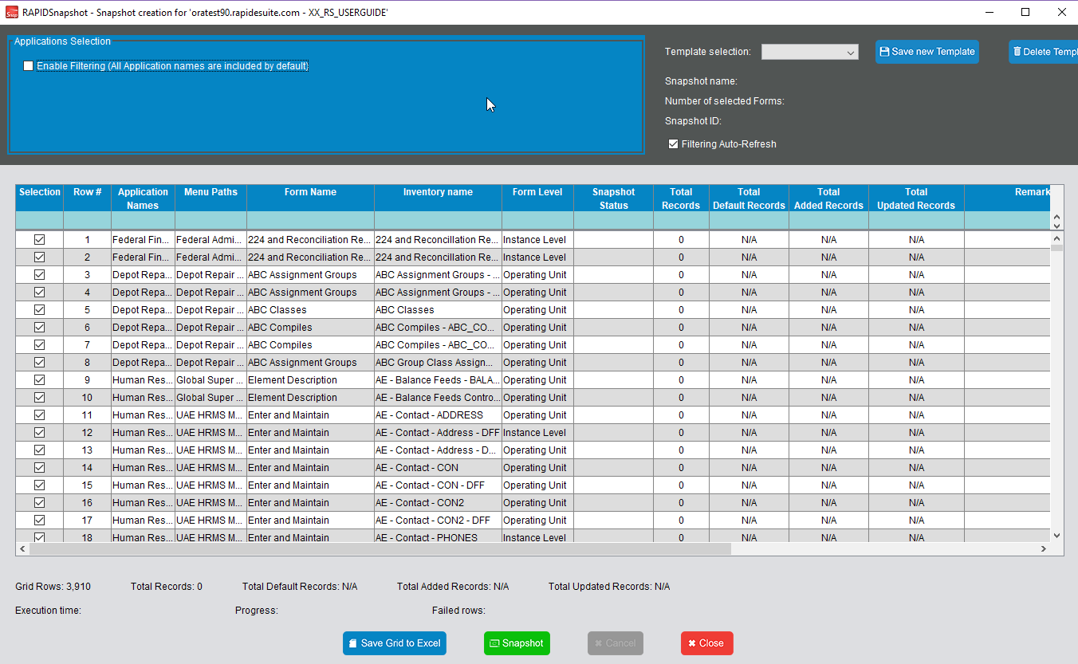

Inventories under 'Human Resource' are in the grid then user can continue taking snapshot.

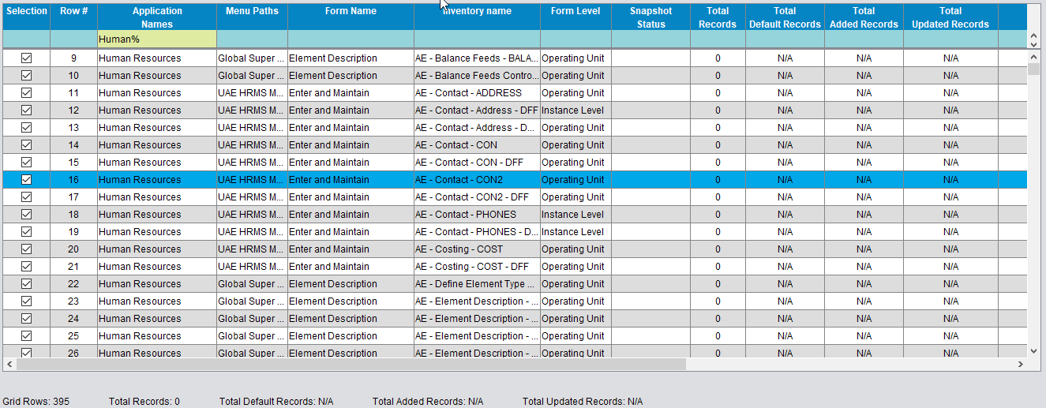

Example 3 : View Snapshot.

The ‘Retrievable’ inventory option turned off is equivalent to thinking in terms of what ‘Retrievable’ inventories are allowed from the database. The inventory snapshot could have happened in the past or about to happen in the future with the ‘Executable’ option ON. Even though a snapshot submission occurs, in either case, retrieval and display of the ‘completed’ inventory collection execution (from the past or future) to the end-user will not occur.

  - Set all inventories under 'Human Resource' can be viewed.

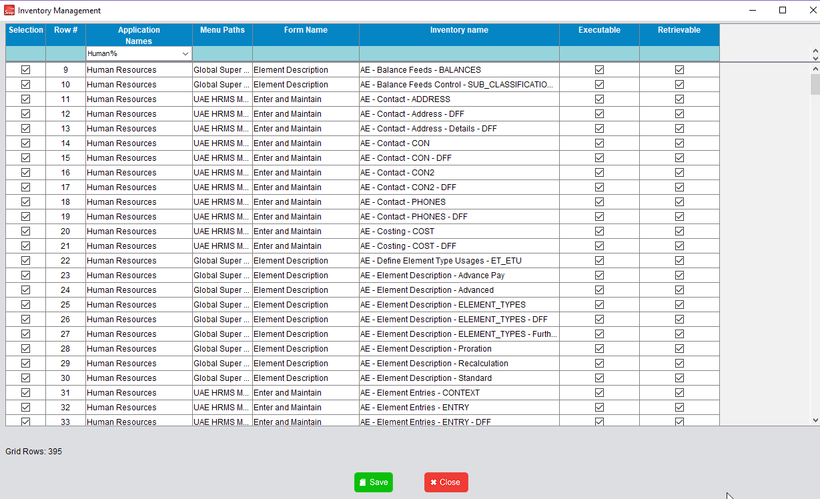
Click View
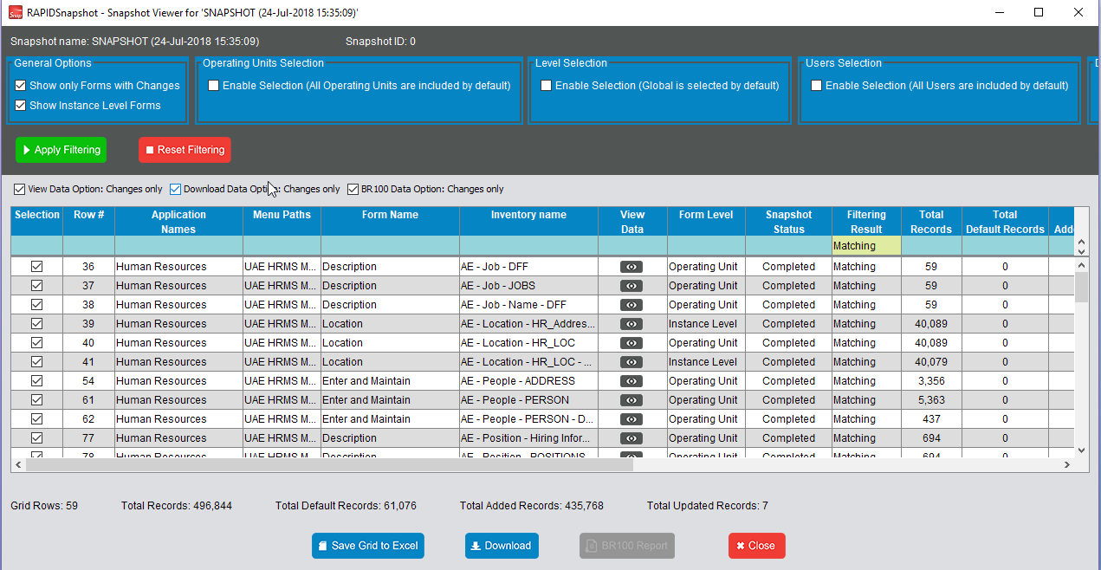

It will show inventories which were taken snapshot and those inventories were set to be listed.

  - Set all inventories under 'Human Resource' cannot be viewed.

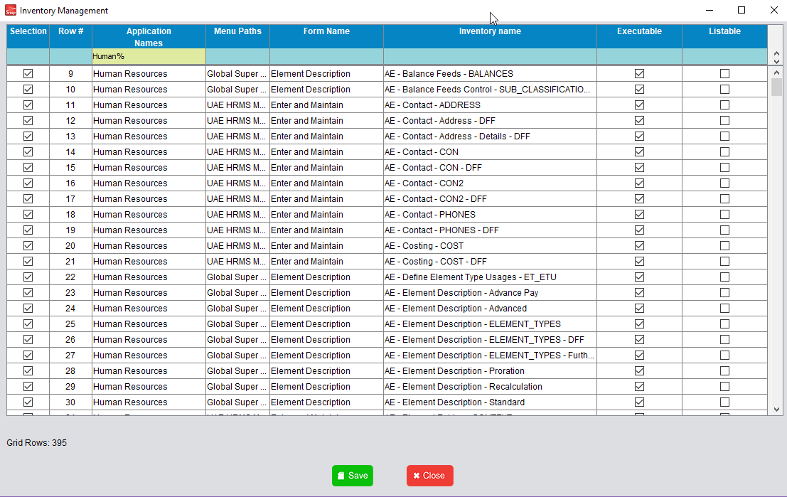

Click View

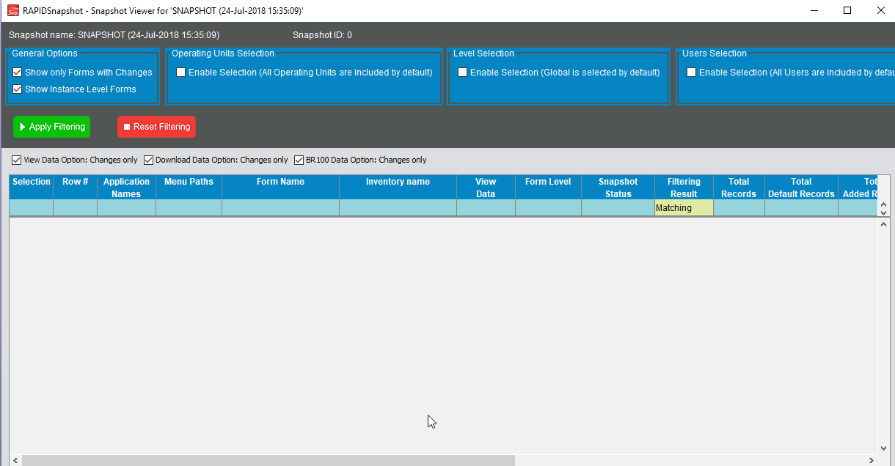

No inventory can be displayed here.

The snapshot inventory data exists in the database, but will not be retrieved by the application for display to the end-use from past or recently occurring snapshot executions.

